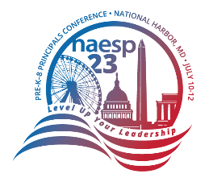
Need help convincing your leadership to let you attend the conference?
Customize this request for approval letter, which will help administrators understand the value of attending the 2023 NAESP Pre-K–8 Principals Conference. You’ll gain great ideas, relevant information, and the resources you need to move your team forward to face new challenges.

Dear ,
I am writing to request approval to attend the NAESP Pre-K–8 Principals Conference, July 8-10, 2023 at the Gaylord National Resort & Convention Center in National Harbor, Maryland.
The NAESP summer conference offers three days of high-quality professional learning and leadership building opportunities for principals. The Conference welcomes thousands of pre-K-8 educators from across the country each summer. This years’ theme, “Level Up Your Leadership,” creates a singular focus for all attendees on effective leadership to improve teaching and student learning.
Participants include school building leaders, school district administrators, teacher leaders, and other education professionals—all gaining new knowledge, instructional strategies, and skills needed to transform student learning while changing the future for our students.
As an attendee, I will participate in presentations from today's most inspiring leaders in education and meet educators who have taken significant steps to help students succeed.
Conference sessions are a combination of large group presentations with nationally recognized speakers, and smaller interactive workshops where I would have the chance to work with education experts. The new information that I will be able to share with the rest of our team will be extremely valuable.
Another option is to send a group of us. If we register a group of three or more, each registrant will save $50 off their registration.
As a member of NAESP, the complete cost of my attendance is listed below:
Registration: $755
Hotel: $243 per night + 18% tax & Fees
Meals: No meals are provided
Travel:
Thank you in advance for your consideration. I believe that attending the NAESP Pre-K–8 Principals Conference will give me access to a breadth of personal and professional opportunities to support me throughout my career. I look forward to hearing from you on this request as soon as possible.
Sincerely,

