Sample Tweets
As your role of school leader grows, so does the NAESP annual conference. In Louisville July 15-17, #NAESP22 will offer more conference strands than ever before, maximizing your learning opportunities and networking possibilities. Learn more and register: http://naespconference.org
Accompanying Image:
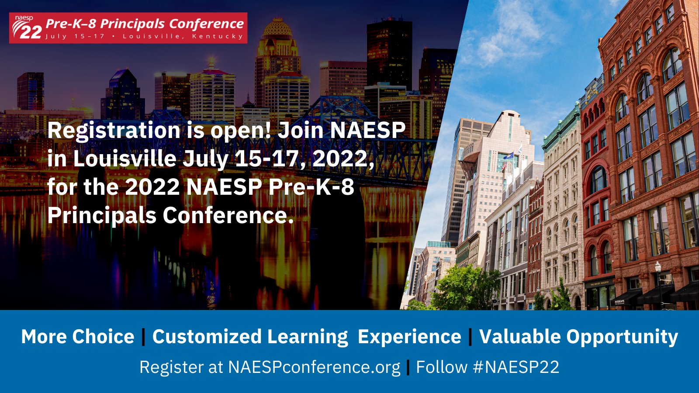

@simonsinek, a thought leader whose “Why” TED Talk is one of the most-watched in the series, is the #NAESP22 opening session speaker. He will inspire you to reach beyond traditional thinking and make a lasting impact in the world. Register: http://naespconference.org
Accompanying Image:
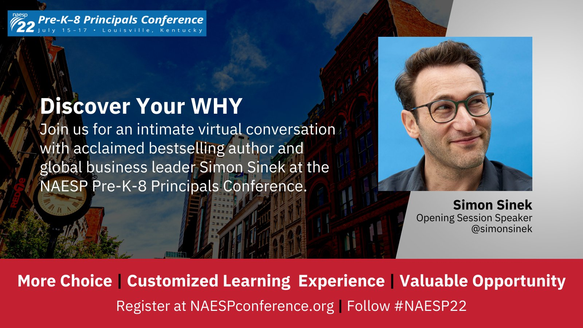

At the 2022 Pre-K–8 Principals Conference in Louisville, keynote speaker @InkyJohnson, former collegiate football player injured on the field, will inspire you to embrace adversity and live life with a greater purpose. Learn more and register at http://naespconference.org. #NAESP22
Accompanying Image:
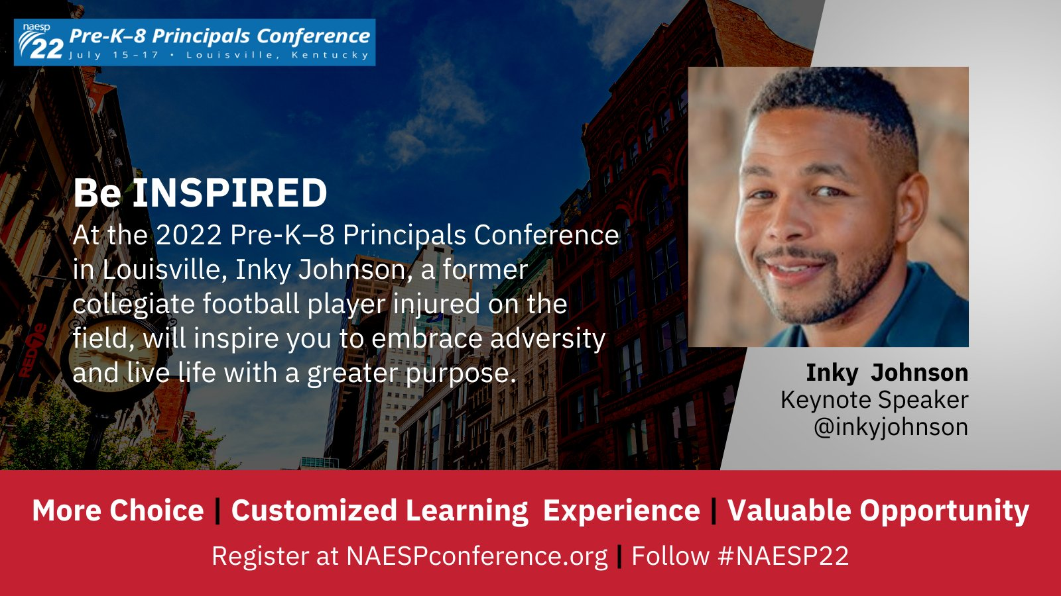

Boost your learning before #NAESP22 July 15-17 in Louisville with pre-conference sessions July 14. Don't miss these powerful sessions from @HeFields3, @jenniferabrams, @ToddWhitaker, @pamallyn, @CaitlinMehra, and @Amberdph. Learn more and register at http://naespconference.org.
Accompanying Image:
