Preview
Jot down any questions you have about this session, or things you hope to learn.

Intentions, Learning Goals: ________________________________________ | Intentions, Community Agreements: __________________________________________
Activity 1: Integration Reflection
- How have you supported your educators in integrating SEL work throughout the school day based on the learning (through Warmth & Support)?

Activity 2: Discussion

Think about a unit or lesson you are about to implement.
- How could you flip the idea of Bloom’s Taxonomy?
- What social and emotional competencies would students need?
- How do you ensure students feel safe and included to engage?

Activity 3: See Balanced Support in Action (video here)
- Note how the teacher uses both active and direct instruction.
- How can you tell the students are emotionally and cognitively engaged?
- Define what SEL skills teacher promotes in students.

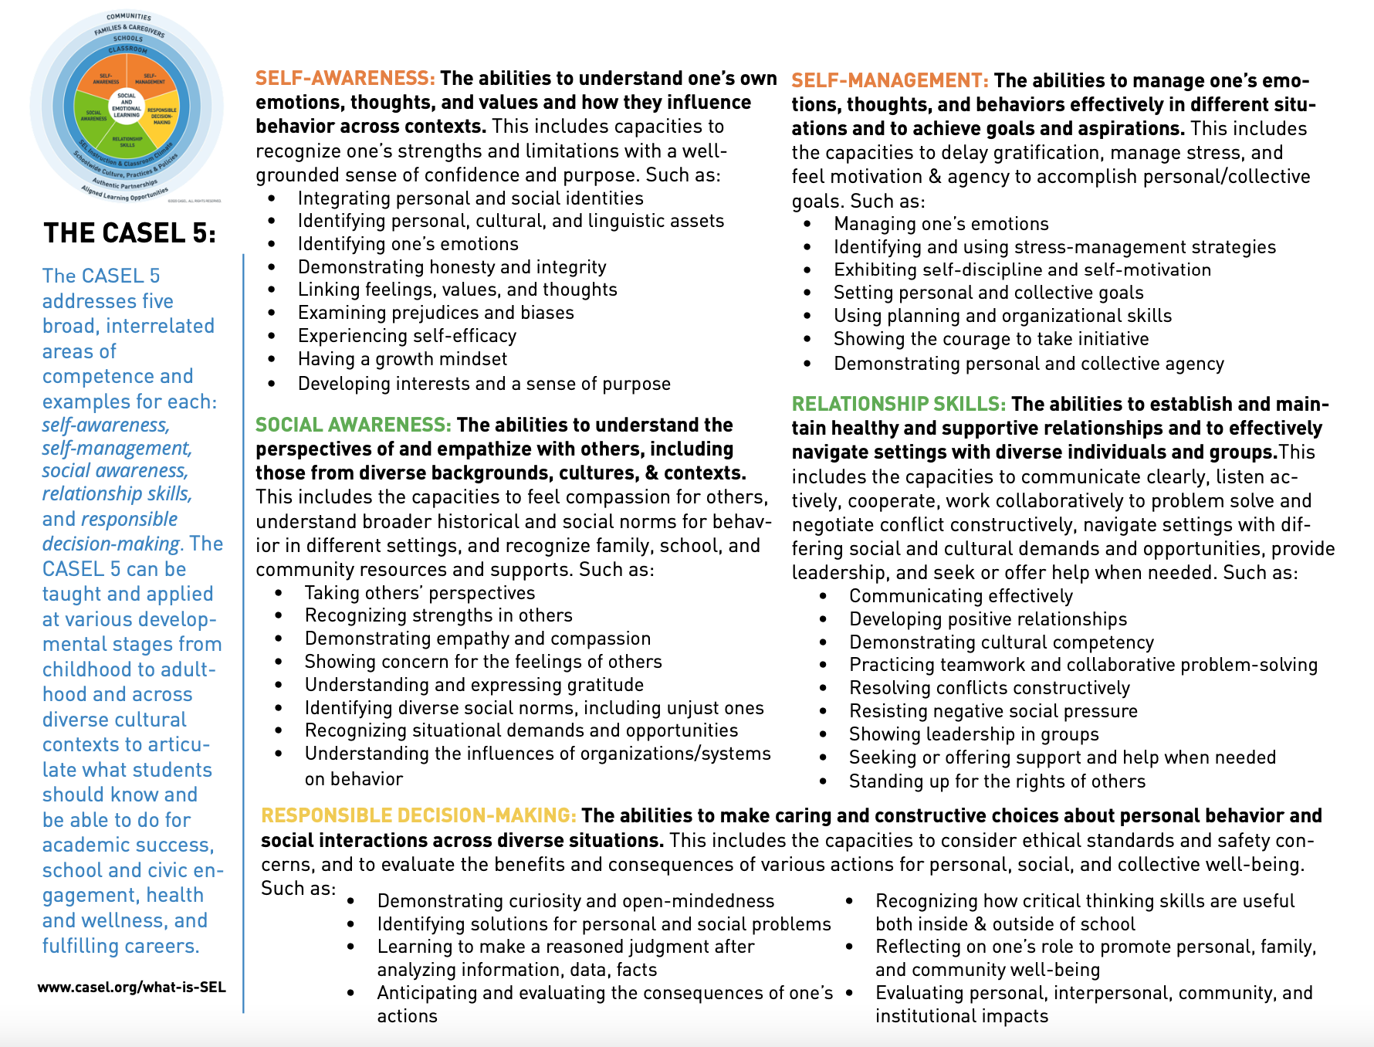

Activity 4: Unit 2, WISES Game
1. Act On It
In breakouts, do one of each of the three cards
- Act on It – Someone Act Out a Feeling
- Do You Get Me – Discuss which decision you would each take and why
- Be Cool – Each of you write a word to describe how you would respond.
2. Do You Get Me
3. Be Cool

Activity 5: Balanced Instruction Academic Integration Taxonomy  Example 1 Taxonomy________ | Definitions:  - Explicit Skill Alignment: A direct link exists between the academic standards and the SEL skills. Specific SEL skills are found within academic standards  - Explicit Strategy Alignment. A direct link exists between the practices required to engage in the content and the SEL skills required to engage in the content practice.  - Ways of Interacting. SEL skills mediate success in academics. Students use SEL skills to interact with content and to interact with others to master academics  - Ways of Being. Based on the content domain, individuals use SEL skills in specific ways. Individuals across content will use similar SEL skills, but how they use the skills varies.
Activity 6 (Reflection): Harmony Connection with Balanced Instruction

- Why is Balanced Instruction important?

- How can Harmony SEL skills promote Balanced instruction?

- What can you do differently in your school to support educators and students?

Activity 5 Example: Combine Ice, Salt, and Water
Instructional Design
Subject/Grade: 3rd Grade | Description of Lesson Activities (considerations for differentiating instruction and incorporating SEL prior to and/or within instruction). | Educator-Led Elements (What do you do during class to guide student learning?)
Duration: 30 minutes
Academic Integration Taxonomy Target Area: Ways of being | - Let students know that in their daily life, it is often helpful to think about their actions, predict what might happen, and then evaluate those predictions after they act; for example, think of times when they decide to share, meet new friends, or try something new.  - Ask students when they have anticipated something and what was the result?  - Explain that similarly, scientists use these skills when they make predictions with their experiments.  - Encourage students to anticipate or predict what will happen when they combine ice, salt, and water using multiple combinations of the elements and using their knowledge of the properties of each.  - After they create their hypotheses, they will have to test their various combinations.  - Then they evaluate whether or not their hypotheses worked out.  - Have students reflect on skill: Similar to how you behaved as a scientist, anticipating and predicting what will happen when you combine elements, and evaluating those predictions, you can approach other areas of your life in the same way. Have students reflect on other areas in which they use these skills. | - Think aloud about a time predicting consequences of actions.  - Facilitate the activity  - Facilitate connecting the science skill to the SEL skill in other domains
10 Educator Practice: Balanced Instruction
Academic Outcomes or Standards  What do you want students to learn or experience in the lesson or unit? |  | Student-Led SEL and Academic Elements (What do students do? How do they interact with each other? How can you use Harmony to support SEL needs?)
Analyze data from testing different combinations of materials to determine outcome best suited for intended purpose. |  | - Brainstorm situations in which they can test their own assumptions about their behavior.  - Think like a scientist, in that they become active consumers of knowledge around them.  - Engage in the activity to test predictions.  - Reflect on other areas in which they actually predict consequences outside of science class.
Harmony SEL Skills and Lessons  What SEL outcomes will you focus on during this lesson? What Harmony lesson is related? |  | Check for Understanding (What ways will you ensure that students mastered the academic social, and emotional skills of the lesson?)
SEL Skill: Anticipate and evaluate the consequences of one’s actions.  Harmony: Talk it Out and Clear it Up |  | - During student reflection, check to see if students can determine how their actions could have influenced a corresponding action or impacted some other people. They are able to justify the connections.

