Preview
Jot down any questions you have about this session, or things you hope to learn.

Intentions, Learning Goals: ________________________________________ | Intentions, Community Agreements: __________________________________________
Activity 1: Kahoot SEL-Academic Integration Review
- What did you learn about SEL based on the recap?
- What are you most excited to learn about in the academic integration?

Activity 2: See Warmth and Support in Action (video here)
- Note how the teacher uses warmth and support practices
- How can you tell the students felt valued and respect?
- Define what SEL skills the teacher promotes in students.

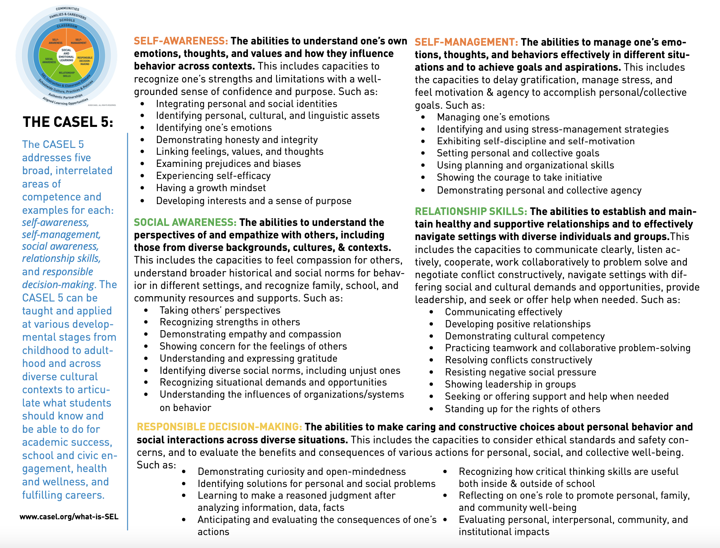
Activity 3: Commonalities Game
Activity 4: Warmth & Support Academic Integration Taxonomy  Example 1 Taxonomy: ___________________ | Definitions:  - Explicit Skill Alignment: A direct link exists between the academic standards and the SEL skills. Specific SEL skills are found within academic standards  - Explicit Strategy Alignment. A direct link exists between the practices required to engage in the content and the SEL skills required to engage in the content practice.  - Ways of Interacting. SEL skills mediate success in academics. Students use SEL skills to interact with content and to interact with others to master academics  - Ways of Being. Based on the content domain, individuals use SEL skills in specific ways. Individuals across content will use similar SEL skills, but how they use the skills varies.
Reflection: Harmony Connection with Warmth and Support  - Why is Warmth and Support important?  - How can Harmony SEL skills promote Warmth and Support?  - What can you do differently in your classrooms? | Harmony SEL Excellence  - 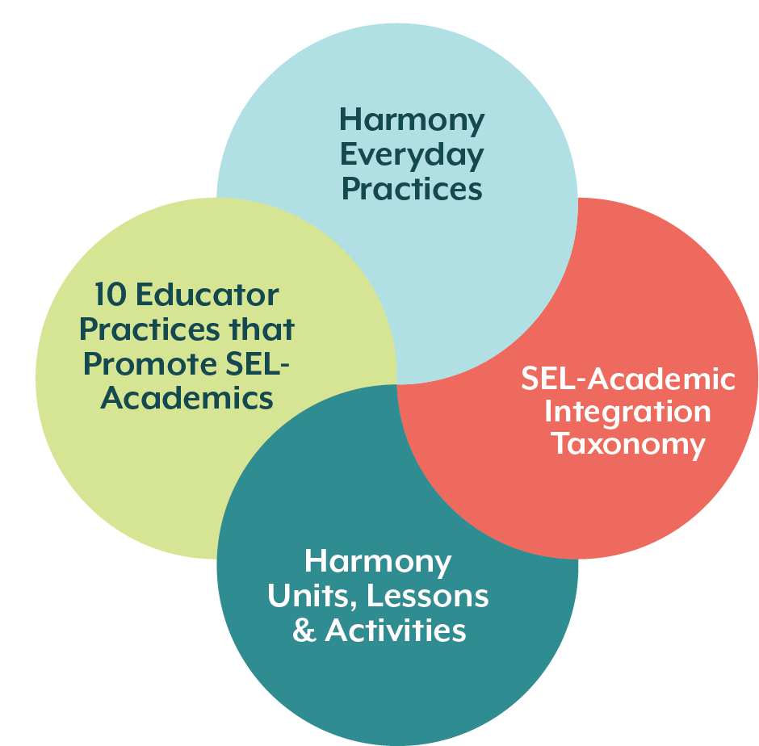

Activity 4: Inclusive and Encouraging Language During Team Sports
Instructional Design
Subject/Grade: Elementary/ PE | Description of Lesson Activities (considerations for differentiating instruction and incorporating SEL prior to and/or within instruction). | Educator-Led Elements (What do you do during class to guide student learning?)
Duration: 15 minutes
Academic Integration Taxonomy Target Area: ways of interacting | - Co-establish and model use of specific, positive language to encourage teammates during group sports (e.g., praising effort with “good try with passing the ball,” praising support of teammates with “nice assist,” or praising improvement with “your toss is getting ore consistent”).  - Facilitate the whole class in generating a list of words and phrases that could be used to praise, support, and provide constructive feedback to teammates.  - Have team co-create a special team cheer.  - Establish a closing routine for the end of each competitive game in which students congratulate all members of their own team and the opposing team. | - Model specific positive language  - Guide students when to use positive language and what it sounds like and feels like.  - Co-create routines with them, providing them a chance to use their voice.
10 Educator Practice: Warmth and Support
Academic Outcomes or Standards  What do you want students to learn or experience in the lesson or unit? |  | Student-Led SEL and Academic Elements (What do students do? How do they interact with each other? How can you use Harmony to support SEL needs?)
Accept differences among classmates in physical development, maturation, and varying skill levels by providing encouragement and constructive feedback. |  | - Brainstorm what positive language sounds like  - Discuss why it is important and the different strengths/assets team members can bring  - Remember to use it during the games  - Engage in a cheer
Harmony SEL Skills and Lessons  What SEL outcomes will you focus on during this lesson? What Harmony lesson is related? |  | Check for Understanding (What ways will you ensure that students mastered the academic social, and emotional skills of the lesson?)
SEL Skill: Recognize strengths in others  Lesson: 1.2. Things We Have in Common, Commonalities Game |  | - Note that each student uses positive language to encourage at least one peer during a game.

Formative Lesson Planning Tool: Integrating SEL Into Instruction

Creating Your Own Academic Integration Examples
To create your own academic integration examples, you can engage in the following steps (recognizing that there are other strategies to implement as well):
- Gain a personal understanding of who your students are as unique individuals. Understand where their interests lie, what assets and gifts they bring to the classroom community, and what they need to be successful in your content area.
- Identify the academic standard that you want to focus on with your students.
- Determine the lesson that you would like to enact for students to master the academic outcome, reflection on which of the 10 educator practices you will use during the lesson.
- Identify the ways in which equity-centered SEL fits within the lesson, reflecting on the following questions:
  - Is the academic outcome also a social and emotional competency (see your state’s SEL standards for example)? [explicit skill alignment]
  - What social and emotional skills are needed for students to engage in the actual lesson? Of those, what social and emotional competencies are strengths? Need additional support? [explicit strategy alignment]
  - Do you need to teach a mini-lesson on a social and emotional competency prior to engaging in the academic lesson to promote positive interactions? [ways of interacting]
  - Is the social and emotional competency specific to the content domain? Does the social emotional skill enhance the gifts students bring to the classroom through their everyday lived experiences? [ways of being]
- Based on the answers to the previous questions, modify the lesson to ensure that you are nurturing the identified social and emotional competency and approach. For example, if it is an explicit alignment, little will need to be modified, whereas ways of interacting may require more substantive modification to ensure students understand the needed social and emotional skill to accomplish tasks successfully with you and their peers.
  - As the lesson is modified, ensure the lesson focuses on the personal and cultural assets of students and ways of interacting, and how the lesson ensures all students’ lived experiences are included.
- Prior to and after the lesson, make time for you! Think about how your own social and emotional competencies can help you to facilitate the lesson; and once completed, think about how the activity went and what additional SEL support you and your students need.

Instructional Design
Subject/Grade: | Description of Lesson Activities (considerations for differentiating instruction and incorporating SEL prior to and/or within instruction). | Educator-Led Elements (What do you do during class to guide student learning?)
Duration:
Academic Integration Taxonomy Target Area: explicit skills, explicit strategy, ways of being, or ways of interaction
10 Educator Practice:
Academic Outcomes or Standards  What do you want students to learn or experience in the lesson or unit? |  | Student-Led SEL and Academic Elements (What do students do? How do they interact with each other? How can you use Harmony to support SEL needs?)
Harmony SEL Skills and Lessons  What SEL outcomes will you focus on during this lesson? What Harmony lesson is related? |  | Check for Understanding (What ways will you ensure that students mastered the academic social, and emotional skills of the lesson?)

