Sample Facebook, Instagram, Twitter Posts and Images

Post 1

FB and IG caption:
NEW! School leaders explain what they need from policymakers to address educator shortages, mental health of students and staff, and lack of PD—issues made worse by crises of 2020-2021. Download the Leaders We Need Now research brief, Principals’ Perspectives on Policy—the final of three briefs in this first-of-its-kind study from NAESP and the American Institutes for Research—which identifies 5 themes policymakers should focus on now. www.naesp.org/LWNN #LWNN

Twitter:
NEW! Policymakers must address educator shortages, student and staff mental health, and lack of PD—issues made worse by crises of 2020-2021—say principals in a #LWNN research brief that identifies 5 themes policymakers should focus on. www.naesp.org/LWNN @NAESP @AIRInforms

Accompanying Image:
LWNN Series.png
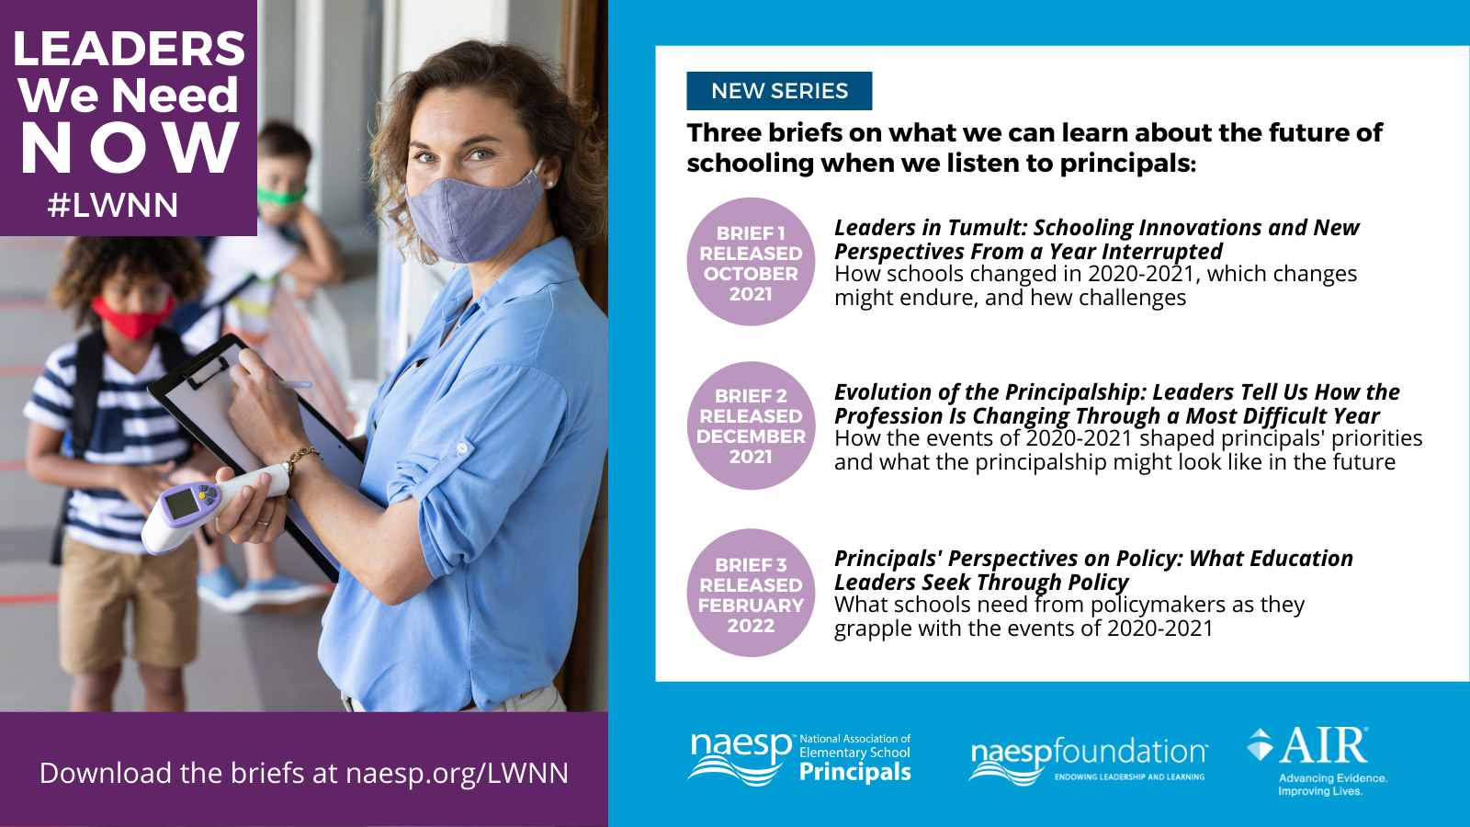

Post 2

FB and IG caption:
NAESP’s Leaders We Need Now series reveals principals’ concerns about educator workforce issues and recruiting new principals. To address this, policymakers must improve succession planning, principal pipelines, and financial incentives. Learn more in the final brief, Principals’ Perspectives on Policy, in the NAESP and American Institutes for Research series. www.naesp.org/LWNN #LWNN

Twitter:
Concerned about recruiting new principals into the profession, school leaders say policymakers must support principal pipelines and improve financial incentives. Learn more in the final brief in the @NAESP and @AIRInforms #LWNN research series. www.naesp.org/LWNN
Image:
LWNN Brief 3 Workforce.png
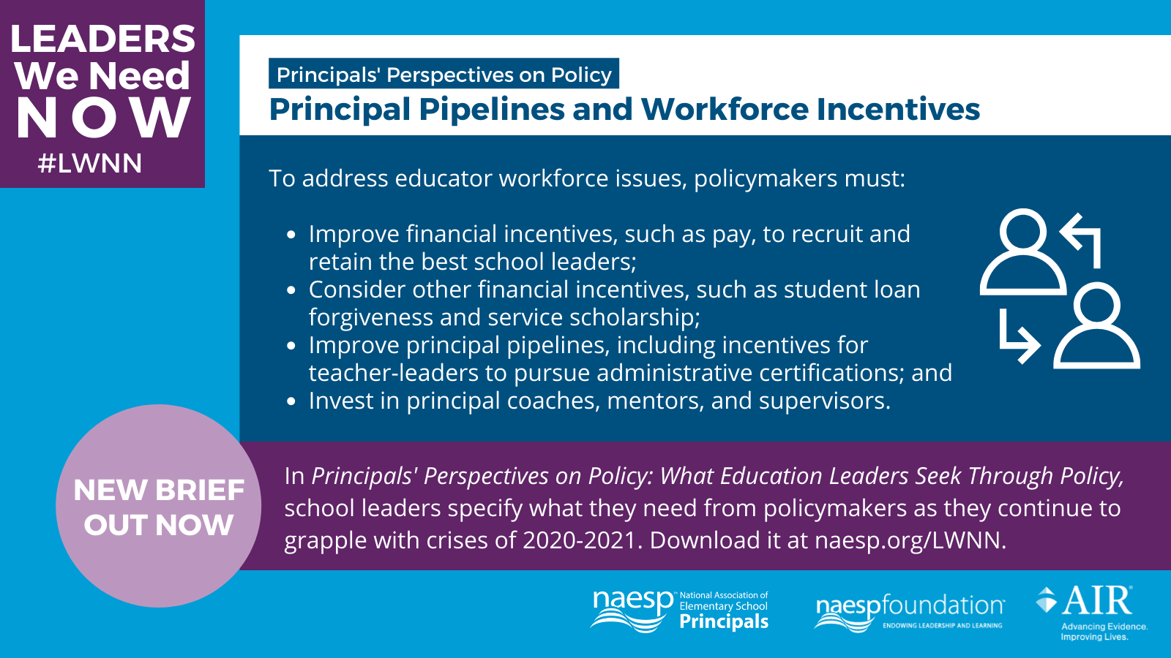

Post 3

FB and IG caption:
In the third research brief from the Leaders We Need Now series principals want policymakers to consider a broader range of school performance, beyond testing, saying standardized tests are overemphasized. Download Principals’ Perspectives on Policy at www.naesp.org/LWNN. #LWNN

Twitter:
NEW! In the third #LWNN research brief, principals say they want policymakers to consider a broader range of school performance, beyond testing, noting standardized tests are overemphasized. Read Principals’ Perspectives on Policy at www.naesp.org/LWNN. @NAESP @AIRInforms

Accompanying Image:
LWNN Brief 3 Testing and Accountability.png
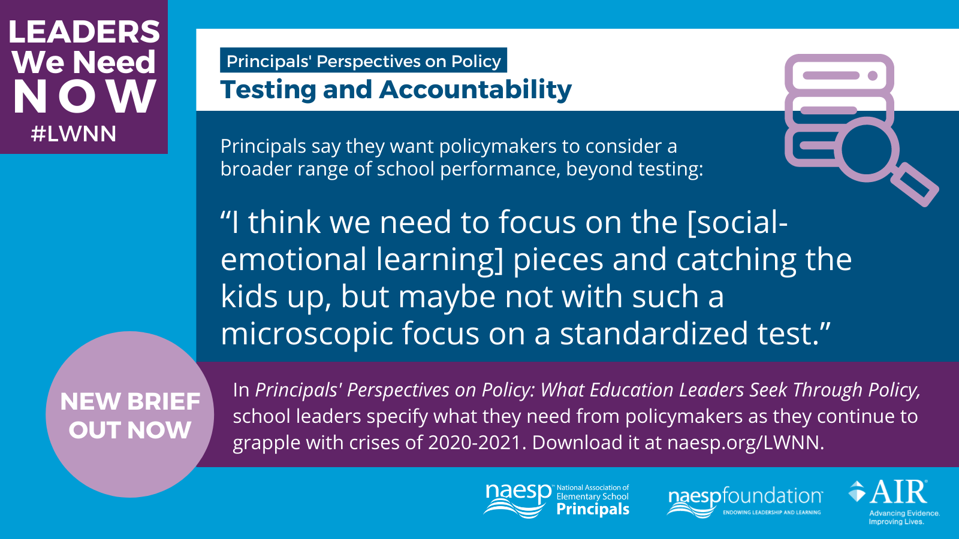

Post 4

FB and IG caption:
Principals emphasized the need for more PD for school leaders, noting a disconnect between academic coursework and actual practices, in the third research brief from the Leaders We Need Now series. They cited the importance of job-embedded practicum, job shadowing, and onsite coaching. Read Principals’ Perspectives on Policy at www.naesp.org/LWNN. #LWNN

Twitter:
Principals need updated PD due to a disconnect between academic coursework and actual practices. In this brief from the #LWNN series, they cited the importance of job-embedded practicum, job shadowing, and onsite coaching. Read more: www.naesp.org/LWNN @NAESP @AIRInforms

Accompanying Image:
LWNN Brief 3 Professional Development.png
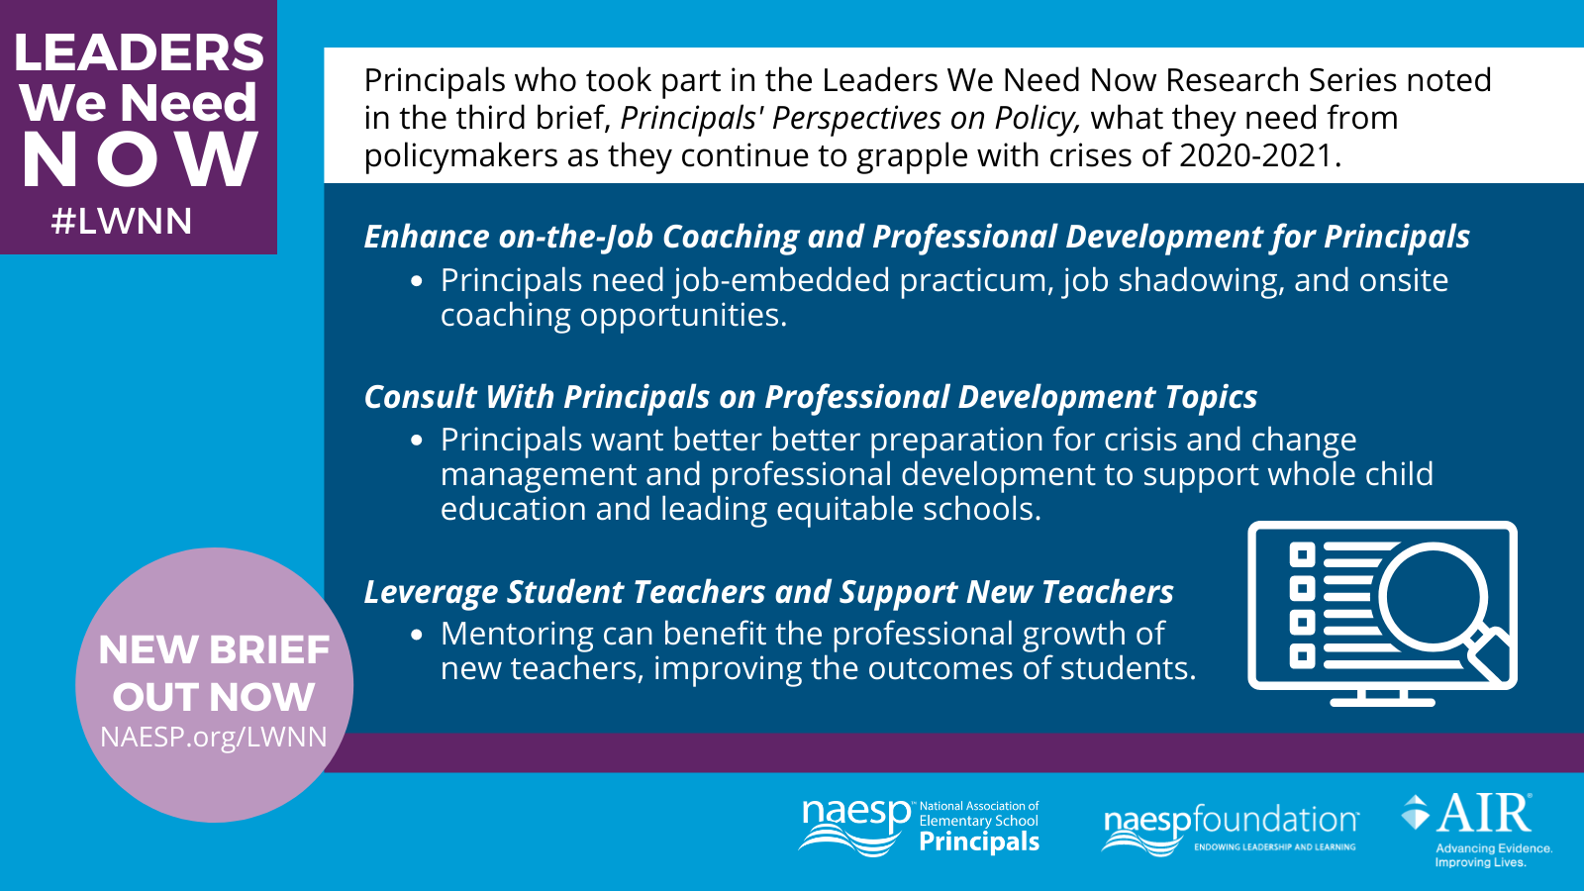

Post 5

FB and IG caption:
Principals confirm in this Leaders We Need Now brief what @NAESP has been saying all along: School leaders must be recognized for their hard work and be meaningfully engaged in policy and legislation discussions. Feedback from principals on legislation improves policy ideas and increases educator buy-in. Read Principals’ Perspectives on Policy at www.naesp.org/LWNN. #LWNN

Twitter:
Principals confirm what @NAESP has said all along: School leaders must be meaningfully engaged in policy and legislation discussions. Establishing a direct "feedback loop" with principals improves policies and increases educator buy-in. www.naesp.org/LWNN @AIRInforms #LWNN

Accompanying Image:
LWNN Brief 3 Engaging Principals.png
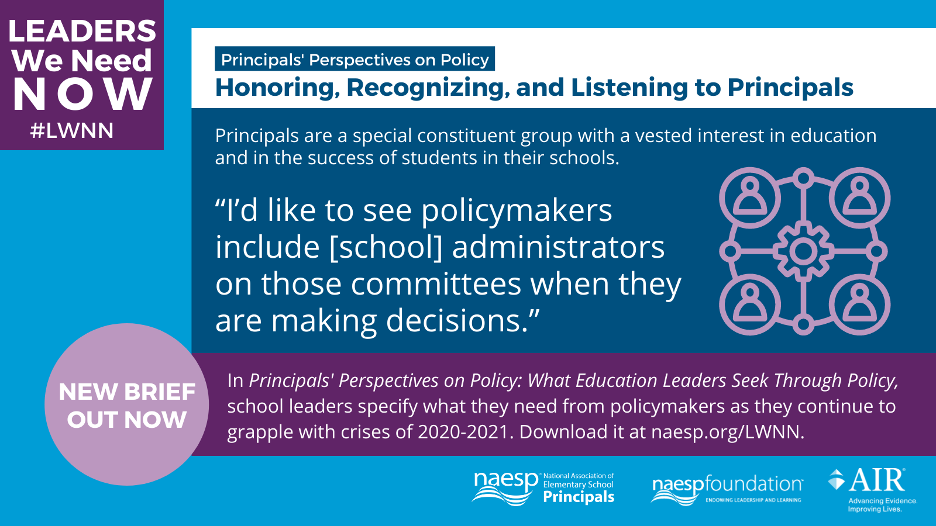

Post 6

FB and IG caption:
Though grateful for federal relief funds, principals in this new Leaders We Need Now research brief express concerns about a “funding cliff”—when additional funds are no longer available, which would hinder sustainable long-term reform. Read more in Principals’ Perspectives on Policy at www.naesp.org/LWNN. #LWNN

Twitter:
Though grateful for federal relief funds, principals express concerns about a “funding cliff”—when additional funds are no longer available, which would hinder sustainable long-term reform. Read Principals’ Perspectives on Policy: www.naesp.org/LWNN @NAESP @AIRInforms #LWNN

Accompanying Image:
LWNN Brief 3 Funding and Resources.png
