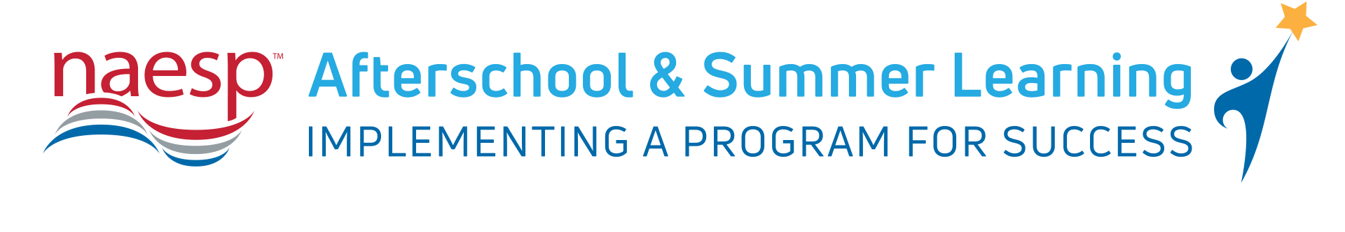Principals are essential to the success of afterschool and summer learning programs that inspire, motivate, and challenge students. NAESP has collected and vetted a variety of resources to help principals and other school leaders expand quality afterschool and summer learning programs for children and youth.
Use the sample social media posts, newsletter articles, and graphics below to help jumpstart or enhance your afterschool and summer learning program.
Sample Social Media Posts
Twitter:
- @NAESP has a new portal to help principals support and champion quality afterschool programs to increase opportunity for all students. Visit #NAESP Afterschool and Summer Learning Portal here: http://bit.ly/2rhPWJG
- Check out @NAESP Afterschool and Summer Learning Portal to see video examples of best practices in afterschool & summer learning. Explore how afterschool partnerships work and access tools & strategies to strengthen afterschool programs. http://bit.ly/2rhPWJG
- Explore this collection of websites for resources and information to help inform and support your afterschool initiatives. via @NAESP & @MottFoundation bit.ly/2olZe2G
Facebook:
- Principals across the across the country are working to ensure that they promote a positive school climate in order to foster the success and emotional well-being of students. Afterschool and summer learning programs are critical components in a continuum of supports for students.
@NAESP has a new portal to help principals support and champion quality afterschool programs to increase opportunity for all students. Read more: http://bit.ly/2rhPWJG
- @NAESP Afterschool and Summer Learning Portal will help principals see video examples of best practices in afterschool and summer learning. Explore how afterschool partnerships work and access tools and strategies to strengthen afterschool programs.
In addition, help school leaders understand the research and evidence on why afterschool and summer learning is so important for a well-rounded education. Visit: http://bit.ly/2rhPWJG
Graphics (Twitter)

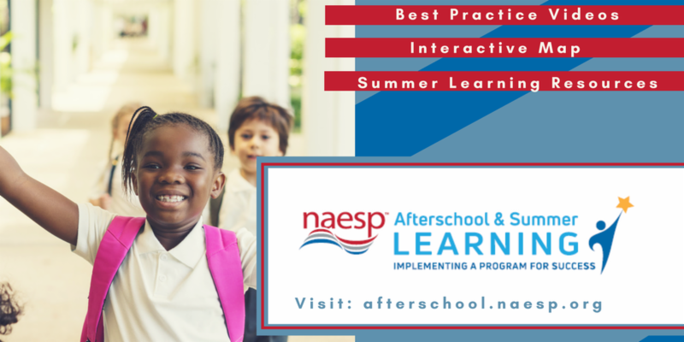

Graphics (Facebook)
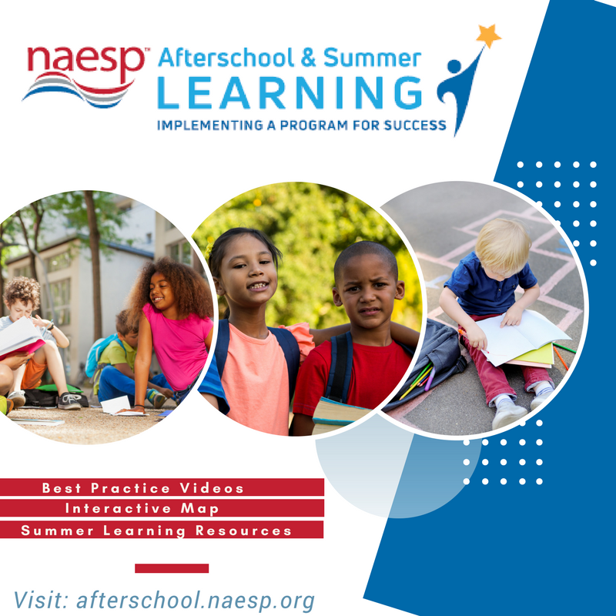
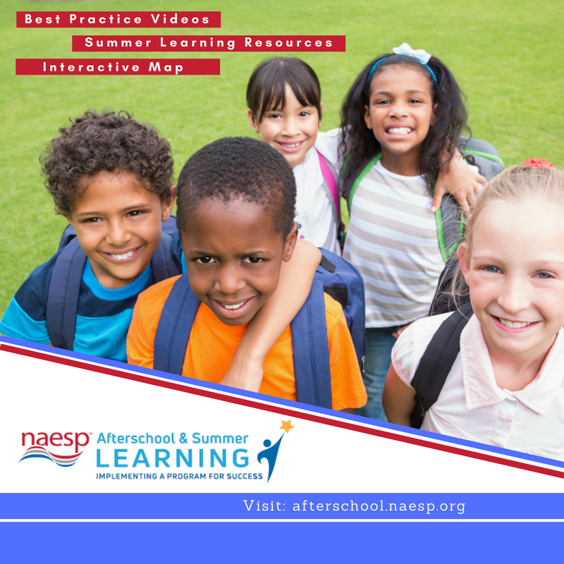

Afterschool Virtual Summit Series:
Register now for one of NAESP’s upcoming Afterschool and Summer Learning Virtual Summit series.
Back to the Basics: How to Effectively Lead an Afterschool and Summer Learning Program
April 10, 2018: 3 p.m. – 4 p.m. EDT
Ready, Set, Go! Resources to Support Afterschool and Summer Learning Programs
April 17, 2018: 3 p.m. – 4 p.m. EDT
Leading the Charge! Combating Afterschool and Summer Learning Myths and Realities
April 24, 2018: 3 p.m. – 4 p.m. EDT

Newsletter Blurb (Approx. 380 words)
Beyond the Classroom: What Principals Want When It Comes to Afterschool and Summer Learning
Learning doesn’t stop when the school day ends. Quality out-of-school (OST) programs are key to students overall success. Research on the impact of after school and summer learning programs have confirmed how students positively benefit academically, improve social and emotional, and health and wellness outcomes.
In the 2017 “Beyond The Classroom: What Principals Want When It Comes to Afterschool and Summer Learning” report from NAESP and the College of Charleston’s Afterschool and Summer Learning Resource Center, survey efforts targeted a range of areas that impact principals and OST programs.
Summary
Findings presented in this report provide important insights into the nature of afterschool and summer programming across the nation. The data indicate that schools and OST programs are inextricably linked, with principals turning to OST programs to supplement in-school instruction.
Principals perceive the outcomes of these programs to be varied in terms of their effectiveness in ensuring homework completion, improving student academic achievement, and in the development of skills and behaviors important for academic success such as getting along with others, motivation to learn, participation in classroom activities, and positive classroom behavior.
Funding
Funding for afterschool programs typically comes from tuition and fees, but for urban and rural schools, as well as schools within the lowest educationally ranked states, federal funding is a significant contributor.
School districts are more prominent funding sources for summer programs but federal funding remains a key source of funding for summer programs in urban and rural communities as well as those within the lowest ranked states.
Afterschool and Summer Management
Most principals indicated they lack the time needed to devote to the OST program and that staffing is a concern. Top priorities among principals are hiring qualified staff, obtaining help in OST program curriculum planning and development, and gaining support to provide engaging experiences during expanded learning opportunities. Urban respondents indicated a need for high quality materials while rural respondents reported that transportation is among their greatest concerns in regards to OST programming
The 2017 national principal survey report also focuses on other elements of afterschool and summer programs including, OST-school partnerships, activities offered in afterschool and summer programming, challenges in OST programming, and more. For the full report, visit http://bit.ly/2BZRDM1.
For more information on NAESP’s Afterschool and Summer Learning Portal visit afterschool.naesp.org.

